PROJECT

Project Title :

OrderOnTheGo: Your On-Demand Food Ordering Solution

Team Name :

Code Crafters

Team Members :

- Chilakala Vishnuvardhan Reddy
- Nischintala Jai Manikanta Chari
- Jupudi Kiran
- Karre Vijaya Lakshmi

Phase-1 : Brainstorming & Ideation

Objective:

The objective of the project is to design and develop a full-stack multi-restaurant food ordering web application using the MERN stack (MongoDB, Express.js, React.js, and Node.js). The system aims to provide a structured, secure, and scalable platform where customers can browse restaurants and place orders, restaurant owners can manage menus and process incoming orders, and administrators can monitor and control overall system operations. The project focuses on implementing role-based authentication, efficient database design, and cloud deployment to simulate a real-world food ordering platform.

Key Points:

Problem Statement:
- Many small and medium-scale restaurants do not have access to a centralized and affordable online ordering system, which limits their digital presence and operational efficiency.
- Many small and medium-scale restaurants do not have access to a centralized and affordable online ordering system, which limits their digital presence and operational efficiency.
- HematoVision Manual order handling and fragmented systems lead to inefficiencies, lack of real-time tracking, and poor coordination between customers and restaurant staff.
- There is a need for a secure, scalable, and role-based web application that allows seamless interaction between customers, restaurants, and administrators within a single integrated platform.

Proposed Solution:
- Develop a full-stack food ordering platform using the MERN stack that supports multiple restaurants within a unified system architecture.
- Implement secure authentication using JSON Web Tokens (JWT) and role-based authorization to ensure proper access control for users, restaurants, and administrators.
- Design a structured order management system that intelligently handles multi-restaurant cart senarios by creating separate orders for each restaurant.
- Provide dedicated dashboards for restaurants and administrators to manage products, monitor orders, approve registrations, and track overall platform performance.

Target Users:

- Customers who wish to browse different restaurants, add food items to their cart, and place orders conveniently through a single web platform.
- Restaurant owners who require a digital solution to maange their menu items, receive and update order statuses, and maintain operational control.
- System administrators responsible for approving restaurant registrations, monitoring users and orders, and maintaining overall system integrity.

Expected Outcome:

- A fully functional, secure, and scalable multi-role food ordering web application deployed on cloud platforms.
- Proper seperation of responsibilities and data visibility between customers, restaurants, and administrators.
- Efficient order processing with correct handling of multi-restaurant scenarios and lates-first order tracking.
- Demonstration of full-stack development capabilities through implementation of authentication, database management, REST APIs, and cloud deployment.

Phase-2: Requirement Analysis

Objective:
Define the technical and functional requirements for the OrderOnTheGo web application.

Key Points:

Technical Requirements:
- Programming Language: JavaScript (Node.js for backend, React.js for frontend).
- Backend Framework: Express.js for building RESTful APIs.
- Databse: MongoDB Atlas for storing users, restaurants, products, carts, and orders.
- Authentication: JSON Web Tokens (JWT) for secure role-based access control.
- Password Security: Bcrypt for hashing user, restaurant, and admin passwords.
- Image Storage: Cloudinary for storing restaurants and product images.
- Deployment Platforms: Render (Backend), Vercel (Frontend).
- Development Tools: VS Code, GitHub, Thunder Client for API testing.

Functional Requirements:
- Allow users to register, log in, and securely access the platform.
- Enable users to browse approved restaurants, view their menu items, add items to cart and place orders.
- Enable restaurants to add, update, and delete menu items with images.
- Provide an admin dashboard to approve restaurants and manage users.
- Display summary statistics including total users, restaurants, orders, and revenue.

Constraints & Challenges:
- Ensuring strict role-based data isolation between users, restaurants, and administrators.
- Handling multi-restaurant order splitting without data conflicts.
- Maintaining secure authentication and preventing unauthorized access.
- Managing cloud-based image uploads and storage efficiently.
- Ensuring smooth deployment and correct environment variable configuration.

Phase-3: Project Design

Objective:
Develop the architecture and user flow of the OrderOnTheGo application.
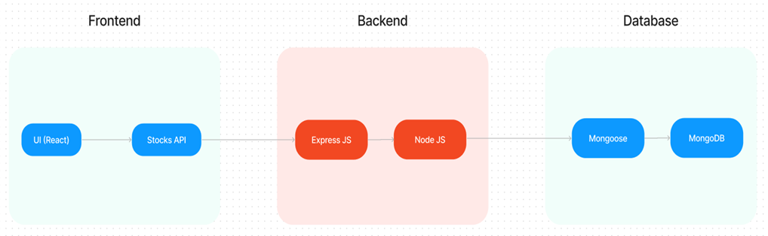

Key Points:

System Architecture:
- Frontend Layer: React.js single-page application built using Vite for fast development and routing.
- Backend Layer: Express.js web server handling RESTful API requests and responses.
- Database Layer: MongoDB storing users, restaurants, products, carts, and orders.
- API Communication Layer: Axios used to connect the frontend with backend REST APIs.
- Cloud Services Layer: Cloudinary used for image storage and retrieva.

User Flow:
- Step 1: The User opens the OrderOnTheGo web application in a browser.
- Step 2: The User registers or logs into the system using secure authentication.
- Step 3: The User browses approved restaurants and views available food items.
- Step 4: The User adds selected items to the cart and proceeds to checkout.
- Step 5: The system groups cart items by restaurant and creates separate orders for each restaurant.
- Step 6: The Restaurant logs into their dashboard and views only their assigned orders.
- Step 7: The Restaurant updates the order status (Accepted, Preparing, Delivered, or Cancelled).
- Step 8: The User tracks order status and views order history from the dashboard.
- Step 9: The Admin logs in to monitor users, restaurants, orders, and overall system activity.

Phase-4: Project Planning

Objective:
Break down development tasks for efficient completion across multiple sprints.

Sprint | Task | Priority | Duration | Deadline | Assigned to | Dependencies | Expected outcome
Sprint 1 | Backend setup and database configuration | High | 4 hours | Day 1 | Member 1 | Node.js, MongoDB Atlas | Backend server connected to database
Sprint 1 | Authentication and role-based access implementation | High | 5 hours | Day 1 | Member 2 | JWT, Bcrypt, Databse models | Secure login system for user, restauratnt, and admin
Sprint 2 | Restaurant and product management module | High | 6 hours | Day 2 | Member 3 | Authentication system, Cloudinary | Restaurants can add/delete products
Sprint 2 | Order management and cart creation | Medium | 6 hours | Day 2 | Member 1 & 4 | Product module, Database models | Multi-restaurant order creation and status updates working
Sprint 3 | Admin dashboard and summary statistics | Medium | 4 hours | Day 3 | Member 2 & 3 | Order and User modules | Admin can manage users, restaurants, and view revenue
Sprint 3 | Testing, deployment, and final review | Low | 3 hours | End of Day 3 | Entire Team | Complete system | Deployed application with stable functionality

Sprint Planning with Priorities

Sprint 1 - Setup & Preparation (Day 1)

High Priority
- Set up the backend project using Node.js and Express.
- Configure MongoDB Atlas database and establish connection using Mongoose.
- Implement JWT-based authentication with role-based middleware.
- Set up the frontend project using React (Vite) and configure routing.

Sprint 2 – Model Development & Integration (Day 2)

High Priority
- Develop user, restaurant, and admin authentication modules.
- Implement product management with image upload using Cloudinary.
- Develop cart functionality with multi-restaurant order splitting.
- Integrate frontend with backend APIs using Axios.

Sprint 3 – Testing, Deployment & Submission (Day 2)

Medium Priority
- Test application workflows across User, Restaurant, and Admin roles.
- Fix authorization issues and ensure strict data isolation.
- Optimize UI responsiveness and improve order display logic.

Low Priority
- Deploy backend on Render and frontend on Vercel.
- Verify production environment variables and API connectivity.
- Prepare project documentation and demonstration materials.

Phase-5: Project Development

Objective:
Implement the core features of the OrderOnTheGo application using MERN stack to build a secure, scalable, and multi-role food ordering platform.

Key Points:

Technology Stack Used:
- Frontend: React.js (Vite), CSS for styling.
- Backend: Node.js with Express.js framework.
- Database: MongoDB Atlas with Mongoose ODM.
- Authentication: JSON Web Tokens (JWT) with role-based middleware.
- Password Security: Bcrypt for hashing credentials.
- Image Management: Cloudinary for storing restaurant and product images.
- API Communication: Axios for frontend-backend interaction.

Development Process:
- Designed MongoDB schemas for Users, Restaurants, Products, Cart, and Orders.
- Implemented secure authentication and role-based access control.
- Developed product management module with image upload integration.
- Built cart system with multi-restaurant order splitting logic.
- Implemented strict restaurant-level order filtering to prevent cross-access.
- Developed admin dashboard with summary statistics (users, restaurants, orders, revenue).

Challenges & Fixes:
- Challenge: Multi-restaurant items appearing in a single order.
Fix: Implemented grouping logic to create separate orders based on restaurantId.
- Challenge: Restaurants viewing orders belonging to other restaurants.
Fix: Applied strict filtering using restaurantId in order queries.
- Challenge: Oldest orders displayed first in dashboards
Fix: Implemented .sort({ createdAt: -1 }) to ensure latest-first order display.

Phase-6: Functional & Performance

Objective:
Ensure that the OrderOnTheGo application performs accurately, reliably, and consistently across various test cases and environments.

Test Case ID | Category | Test Scenario | Expected Outcome | Status | Tester
TC-001 | Functional Testing | User registration and login | User successfully authenticated and redirected to dashboard | Passed | Tester 1
TC-002 | Functional Testing | Add product to cart and place order | Order created successfully and stored in database | Passed | Tester 2
TC-003 | Functional Testing | Multi-restaurant cart checkout | Separate orders created per restaurant | Passed | Tester 3
TC-004 | Functional Testing | Restaurant updates order status | Order status updates correctly and reflects on user dashboard | Fixed | Tester 1
TC-005 | Performance Testing | Load admin dashboard with multiple records | Dashboard loads within acceptable time (<3 seconds) | Passed | Tester 2
TC-006 | Error Handling | Attempt unauthorised access to protected route | Access denied with proper error message | Deployed | Developer
TC-007 | UI  Responsiveness | Test application on browser | Layout adjusts properly on mobile devices | Needs Optimization | Tester 3
TC-008 | Deployment Testing | Access live application via Vercel and Render | Application loads and APIs function correctly in production | Deployed | DevOps

Project Implementation and Execution

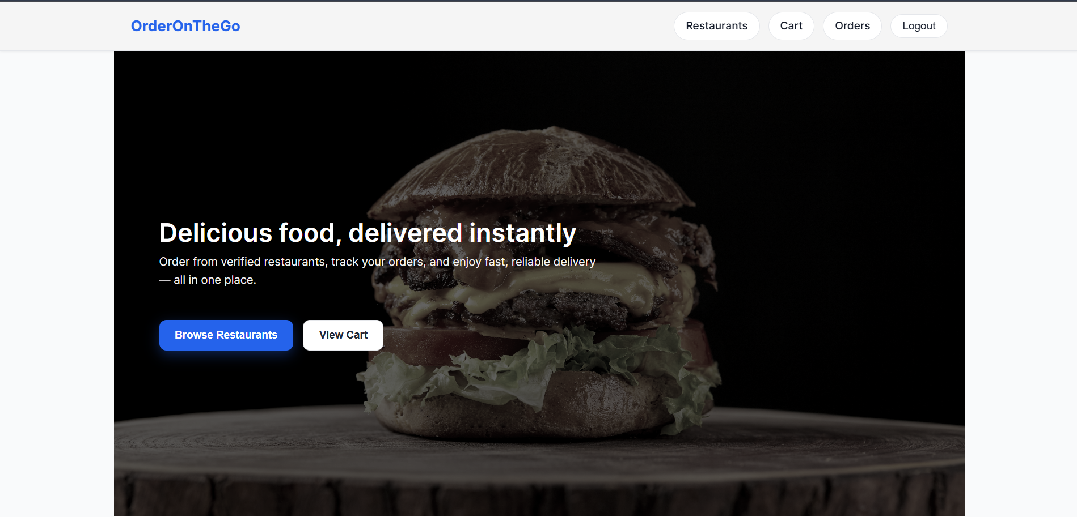
Landing Page

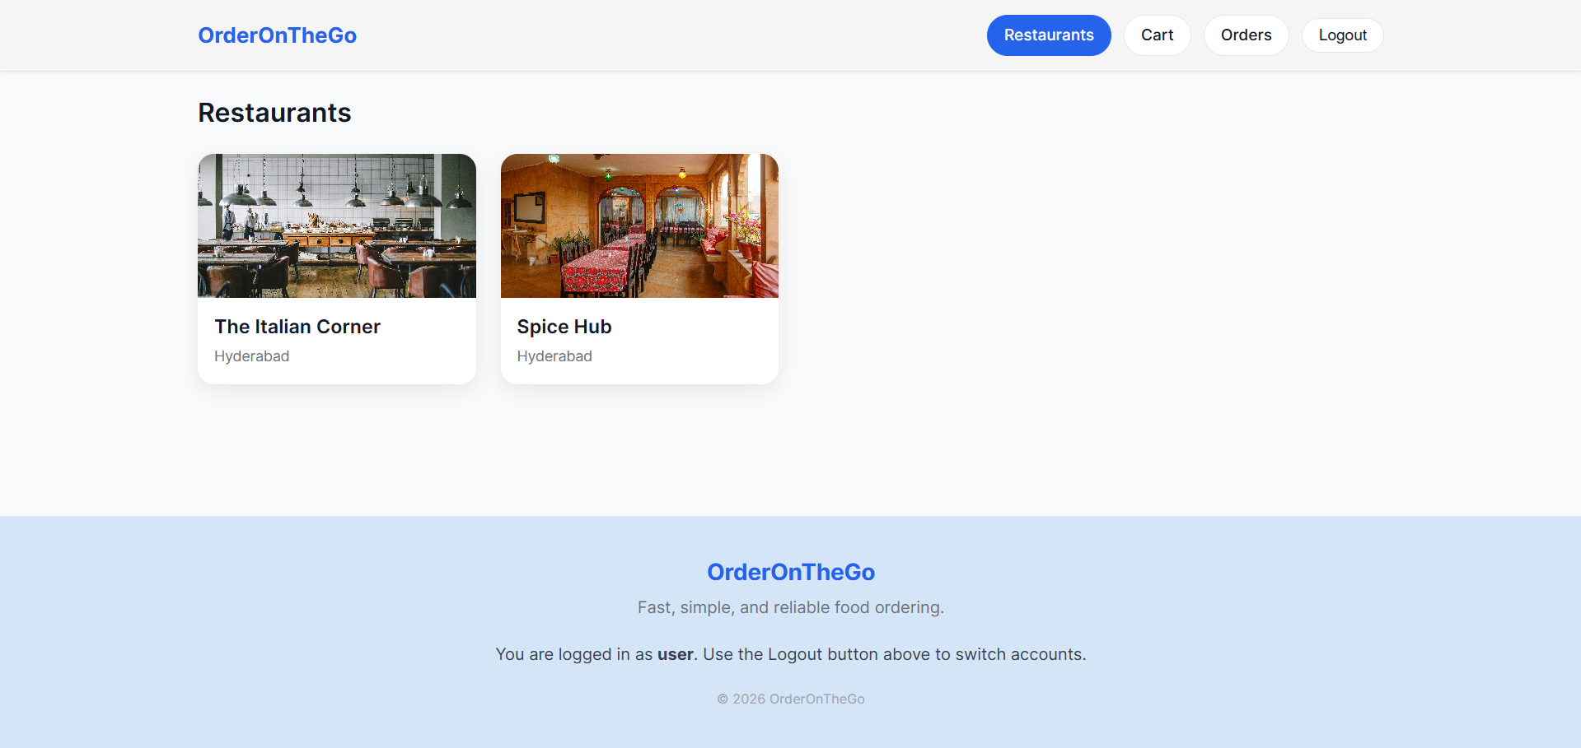
Restaurants

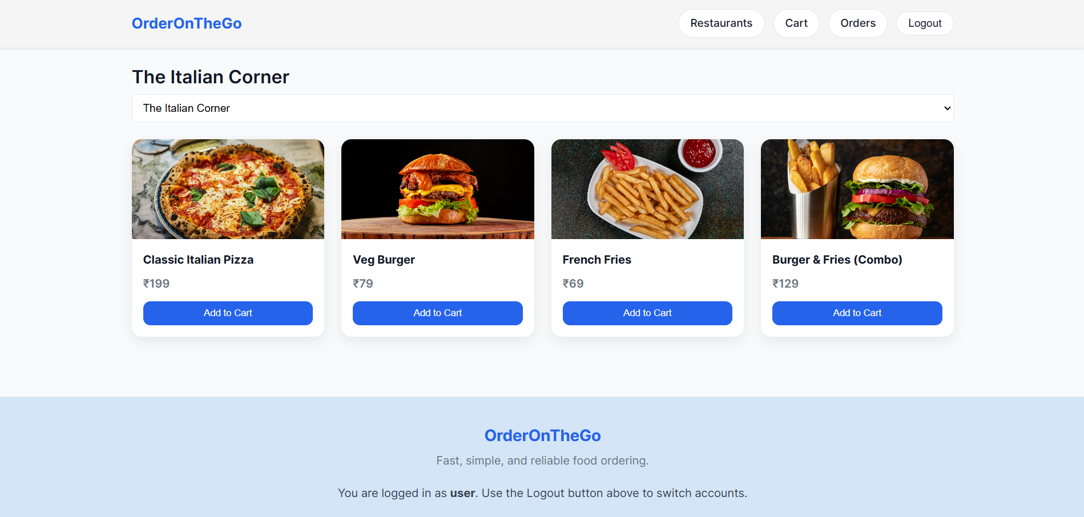
Restaurants Menu

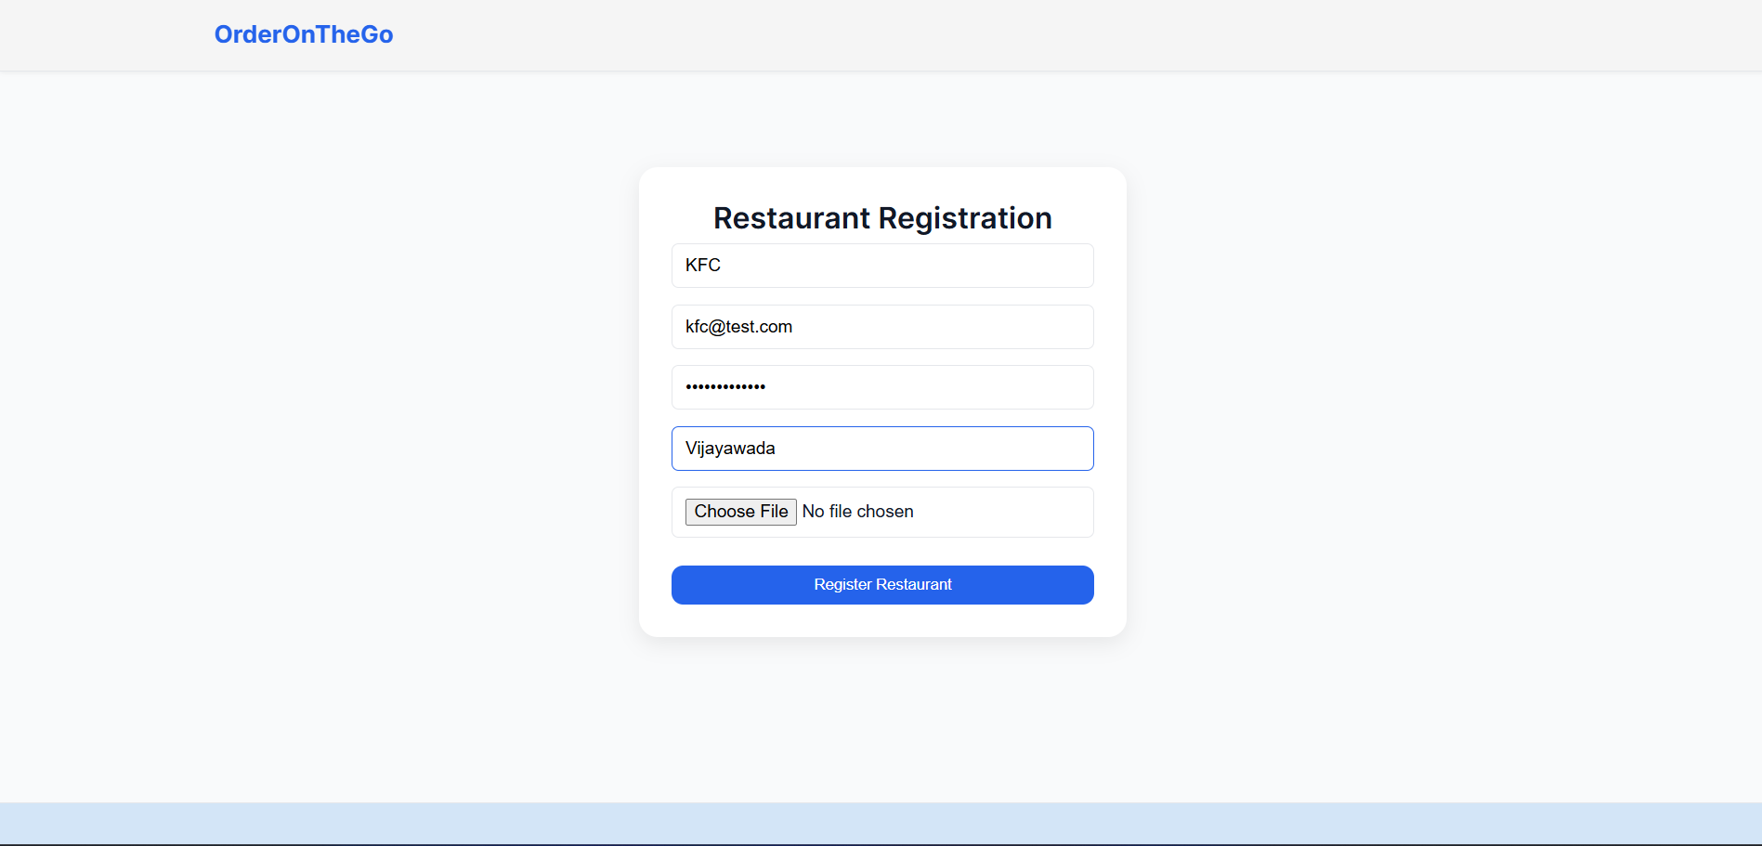
Authentication

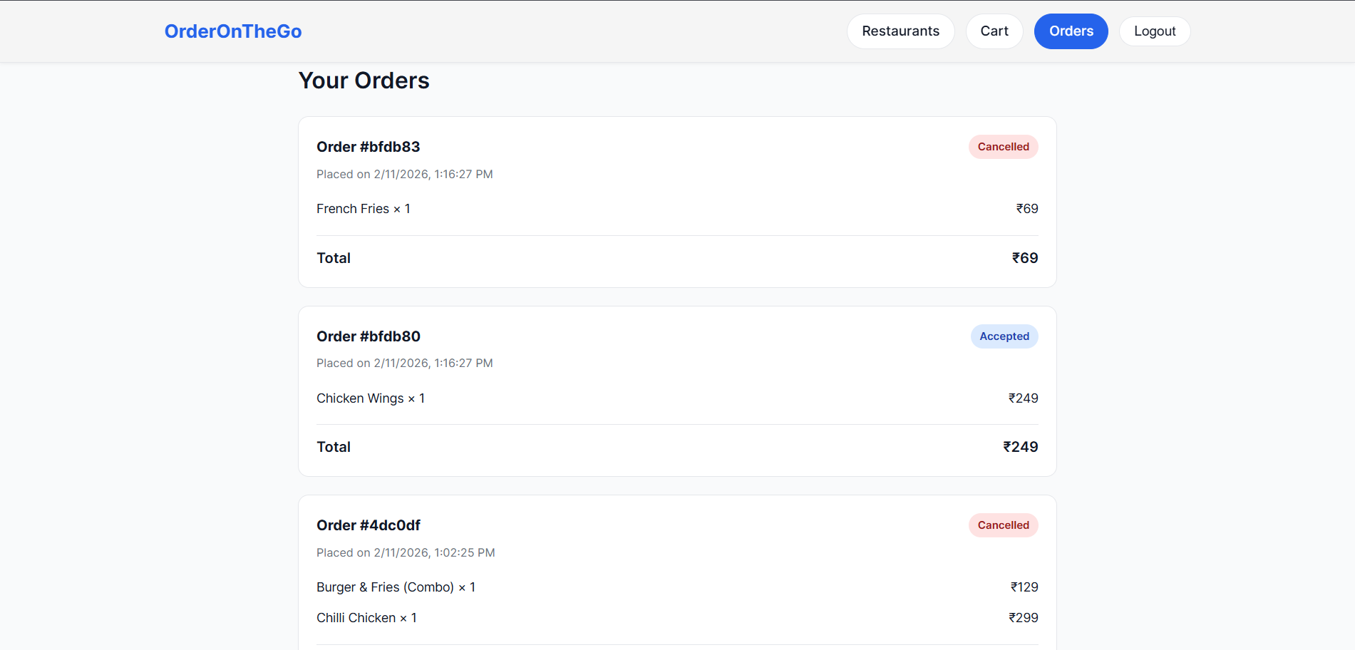
User Profile

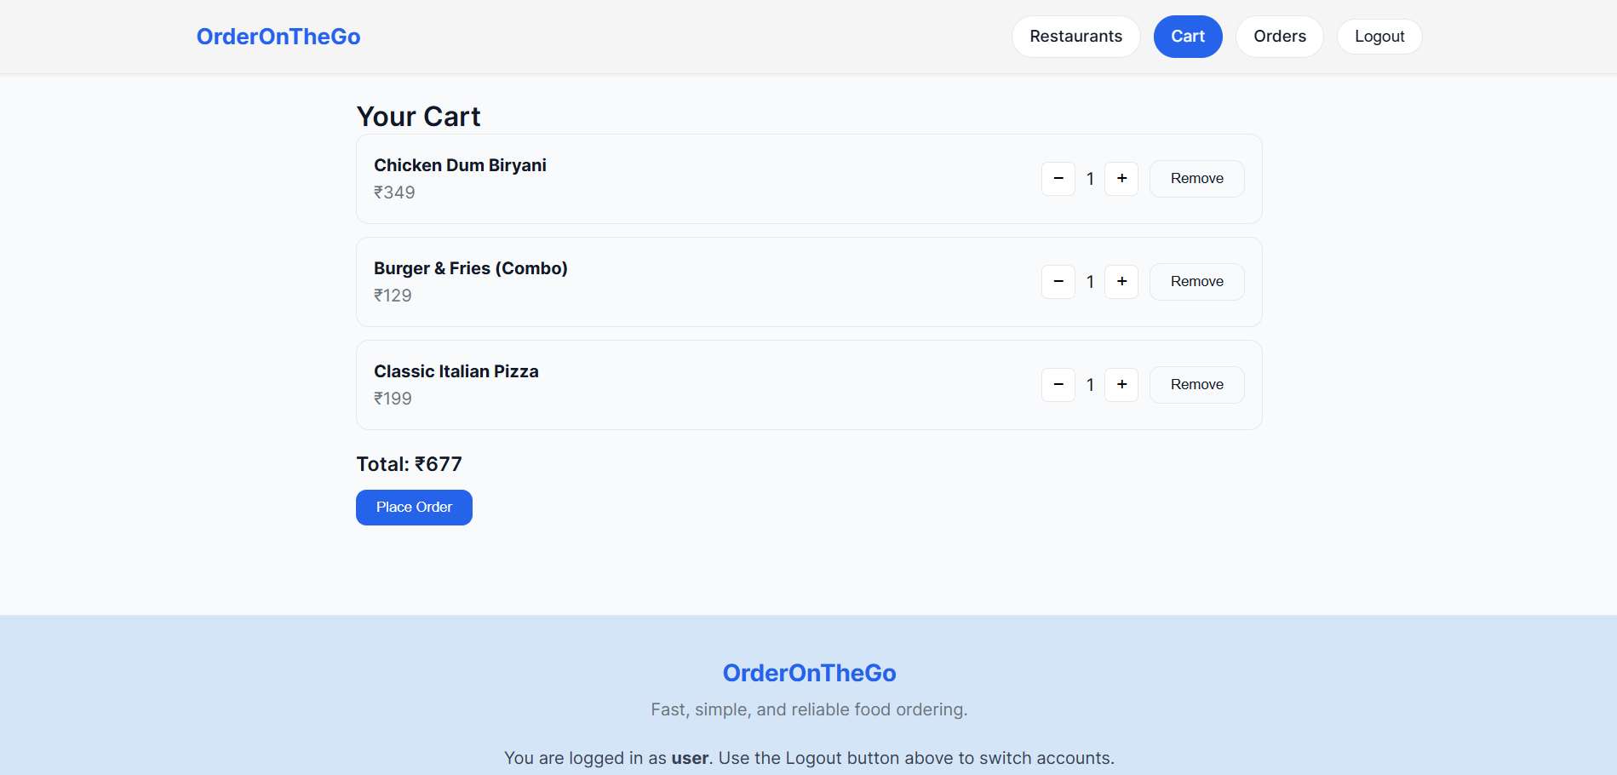
Cart

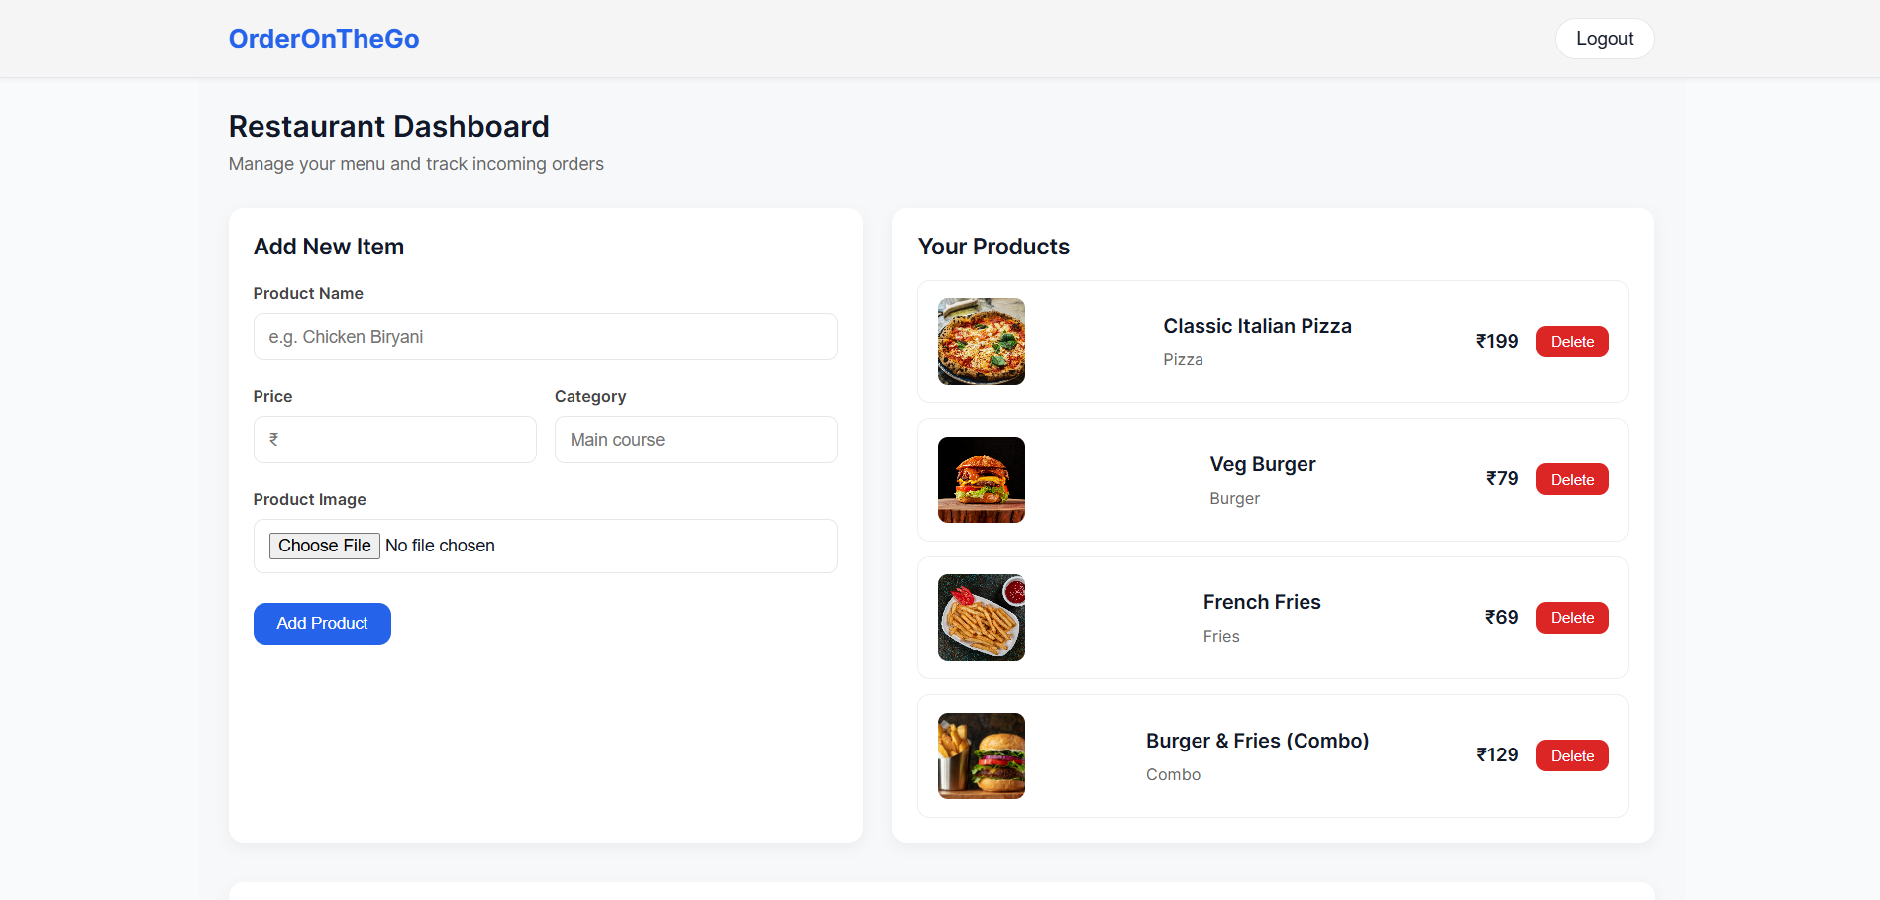
Restaurant Dashboard

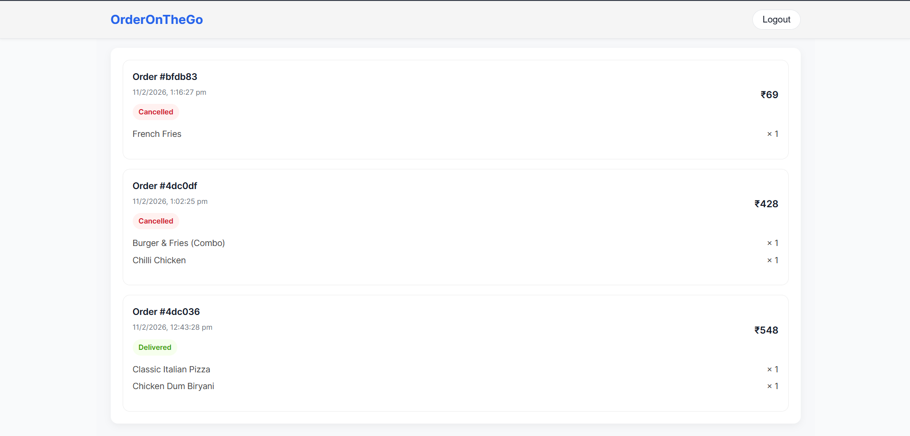
Restaurant Orders

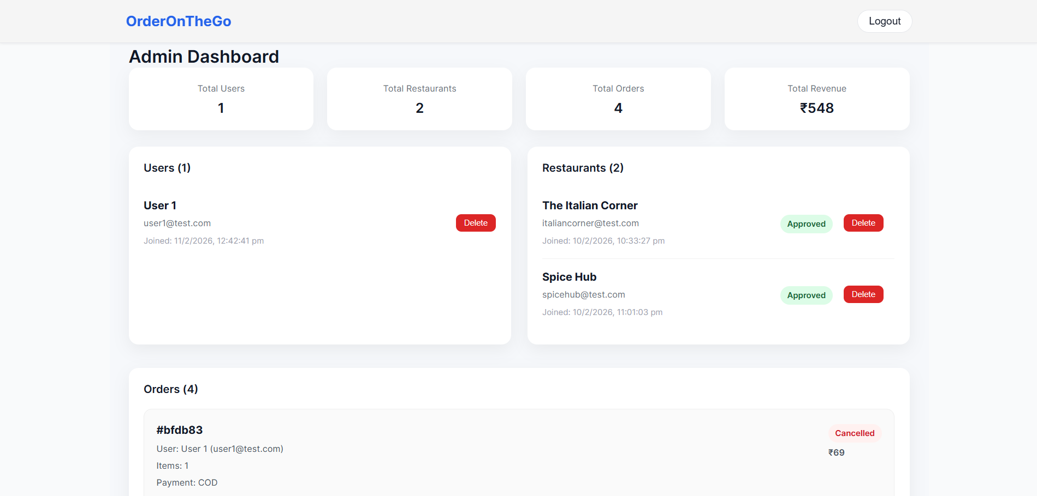
Admin Dashboard

Project Link: https://orderonthego.vercel.app

